CanSat
Temperature
1. DS18B20 Temperature sensor
Arduino

DS18B20 | Arduino
GND | GND
DQ | Any digital pin (with 4.7k Ohm pull-up resistor)
VDD | 5V (normal mode) or GND (parasite mode)
- Connection : Parasite mode
- Libraries: 1. Dallas
2. OneWire
- Sample code: .DS18B20.ino

2. LM35 Temperature Sensor
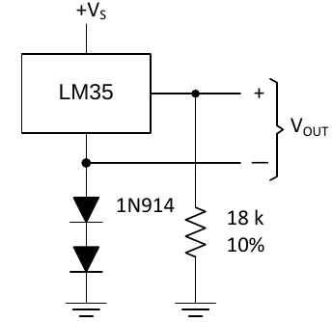
Power supply : 5v
Sample code: .lm35.ino

Humidity
1. DHT22/AM2302 humidity sensor
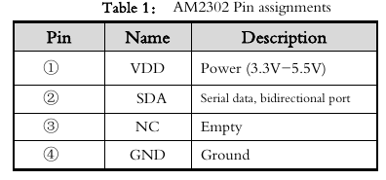
Libraries: Adafruit and DHT
3 Pin DHT22 | Arduino
DAT | Digital pin 2
VCC | 5 V
GND | GND
Sample code: .AM2302.ino

2. SHT21
voltage supply: 2.1 – 3.6 V
Libraries: HTU21D sparkfun
Sample code: .SHT21.ino

> VCC to 3.3V of Arduino uno
> GND to GND of Arduino uno
> SDA to A4 of Arduino uno
> SCL to A5 of Arduino uno
Pressure & altitude
1. BMP180
VCC --> 3.3V
GND --> GND
SCK --> A5
SDI --> A4

Libraries : Wire
Sample code : .BM280.ino
2. BMP280
Same connection as above

Ozone
1. MQ131
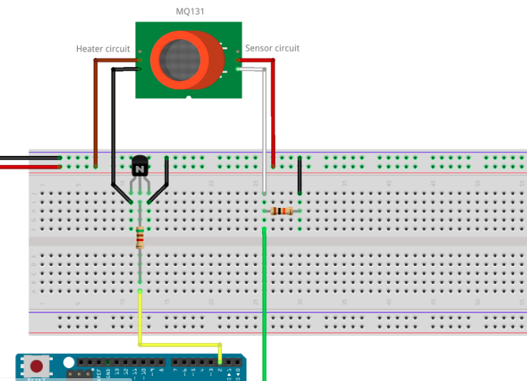
Sample code: .MQ131.ino

Data transmission
Digi XBee-PRO® 900HP
Long Range 900 MHz OEM RF Module
- Superior LOS range of up to 28 miles* with high-gain antenna
- Simplified AT command set and advanced XBee API
- Over-the-air firmware updates
- Software-selectable channel mask for interference immunity
- Advanced sleep modes: sleeping routers, pin sleep, cyclic sleep
connection.
/*TODO*/
ALTIUM CIRCUIT DESIGNER

Designing and generation of pcb grabcad files for pcb milling
Strategy: > Download the 2020 cracked versions – file size 2.4 gb
> Install the crack
> Learn the basics of its use.
> proceed to circuit implementation

